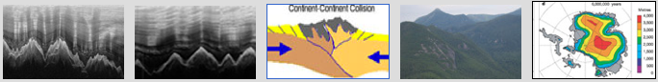

MOUNTAIN ACTIVITY 2

STUDENT RESPONSE PAGE NAME_______________________

GHOST HUNTING: FINDING HIDDEN MOUNTAINS!

HOW DO THESE MOUNTAINS MEASURE UP?

- HOW BIG IS THE GABURTSEV MOUNTAIN RANGE ?______________*

- HOW DOES THIS COMPARE TO YOUR STATE? WHAT IS THE AREA OF YOUR STATE?_________________*

- WHICH ONE IS LARGER, YOUR STATE OR THE GAMBURTSEVS?__________________

- WHAT STATE FROM THE LIST IS CLOSEST IN SIZE TO THE GAMBURTSEV MOUNTAIN RANGE?_______________

* BE SURE TO INCLUDE UNITS IN STEPS #1 AND #2

WHAT’S IN A LAYER?

- ON THE IMAGE BELOW LABEL THE OLDEST ICE AND THE YOUNGEST ICE ON THE Y AXIS.

- MARK THE OLDEST LAYER OF WINTER ICE YOU CAN TRACE ACROSS THE IMAGE. WHAT DEPTH IS THIS?_____________

- DOES IT FLOW IN A STRAIGHT LINE OR DOES IT FOLLOW THE SHAPE OF THE MOUNTAINS?____________

- HOW FAR UP IS THIS LAYER OF ICE FROM THE TALLEST MOUNTAIN PEAKS?_______________

- HOW FAR UP IS THIS LAYER OF ICE FROM THE SHORTEST MOUNTAIN PEAKS?_______________

- DID YOU THINK THE MOUNTAINS WOULD HAVE THIS KIND OF IMPACT ON THE ICE?_________EXPLAIN YOUR ANSWER ____________________________________________________________________________________________________________________________________



